**/blend**

[**https://s.mj.run/zjMULKb9TTc**](https://s.mj.run/zjMULKb9TTc) [**https://s.mj.run/_0iqrSL5W70**](https://s.mj.run/_0iqrSL5W70)

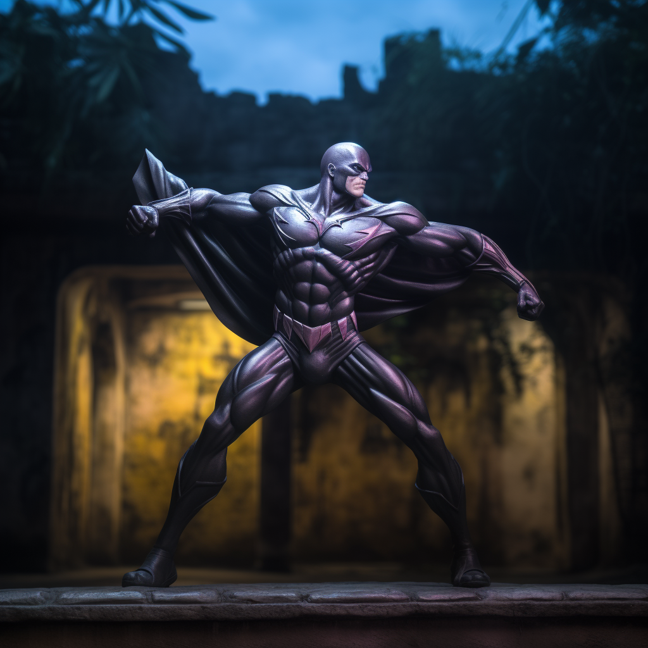

1️⃣ super hero batman statue in an alleyway, in the style of dark silver and light magenta, dynamic action painting, detailed miniatures, angenieux 45-90mm f/2.8, saurabh jethani, graceful poses, strong lines

2️⃣ an action figure statue is in front of an illuminated tree, in the style of dramatic light and shadow, precision painting, dark silver and light magenta, superheroes, art of tonga, strong diagonals, detailed penciling

3️⃣ the batman dc comics figure v9 riutokyo, in the style of long exposure, light magenta and silver, speedpainting, naturalistic shadows, romanesque art, diorama, strong lines

4️⃣ Batman's armor in dark lighting, in the style of light silver and magenta, diorama, boris grigoriev, traditional poses, dynamic outdoor shots, antonio canova, hercules seghers

[**https://s.mj.run/t66qFQlI_0I**](https://s.mj.run/t66qFQlI_0I) [**https://s.mj.run/2ybJRenaN4M**](https://s.mj.run/2ybJRenaN4M)

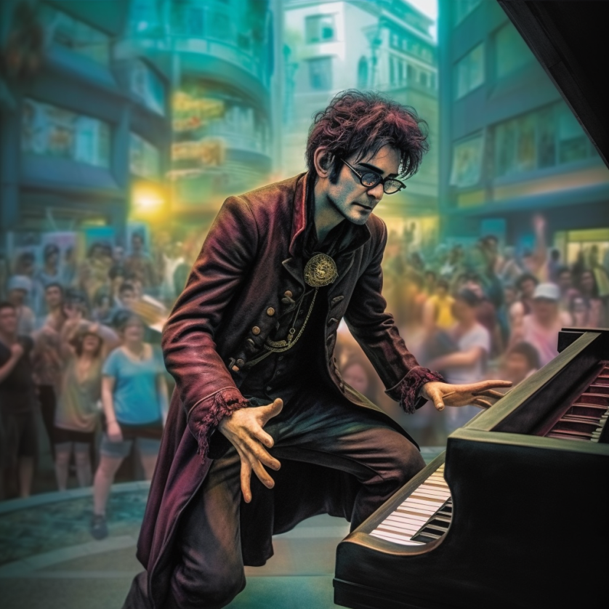

1️⃣ a man with glasses playing a piano in front of a crowd, in the style of fantastical street, simon bisley, indian pop culture, tim burton, celestialpunk, herman brood, dark violet and gold

2️⃣ an image of a man playing a piano before a crowd, in the style of vivid comic book artist, cristina mcallister, street scene, tim burton, marc simonetti, indian pop culture, sharp/prickly

3️⃣ a man playing a piano with a crowd around him, in the style of vivid comic book artist, fantastical street, eerily realistic, dark gold and violet, mallgoth, city portraits, classic rock

4️⃣ a man playing the piano with people surrounding him, in the style of fantastical street, vivid comic book artist, eerily realistic, mallgoth, dark gold and violet, sharp/prickly, iconic

[**https://s.mj.run/JnytkoO1Rz4**](https://s.mj.run/JnytkoO1Rz4) [**https://s.mj.run/ZkSgfRjVeG0**](https://s.mj.run/ZkSgfRjVeG0)



1️⃣ the movie by lilian waugh has a woman holding flowers on a boat, in the style of portraits with soft lighting, georg jensen, mary beale, beige and amber, softbox lighting, bess hamiti, digitally manipulated images

2️⃣ joan criesen movie poster in a coat of arms, in the style of light-filled seascapes, portraits with soft lighting, photo taken with nikon d750, colorized, feminine portraiture, dark beige and light amber, striped arrangements

3️⃣ the most beautiful ship in the world starring benjamin franklin, in the style of romantic drama, light-filled seascapes, feminine portraiture, 8k resolution, art of burma

4️⃣ the ship in the night 'the boat that never came', in the style of annie leibovitz, beige and amber, georg jensen, portraiture with emotion, uhd image, mary beale, 8k resolution

[**https://s.mj.run/iZr0NiNZr0A**](https://s.mj.run/iZr0NiNZr0A) [**https://s.mj.run/H1vea9qtjK4**](https://s.mj.run/H1vea9qtjK4)

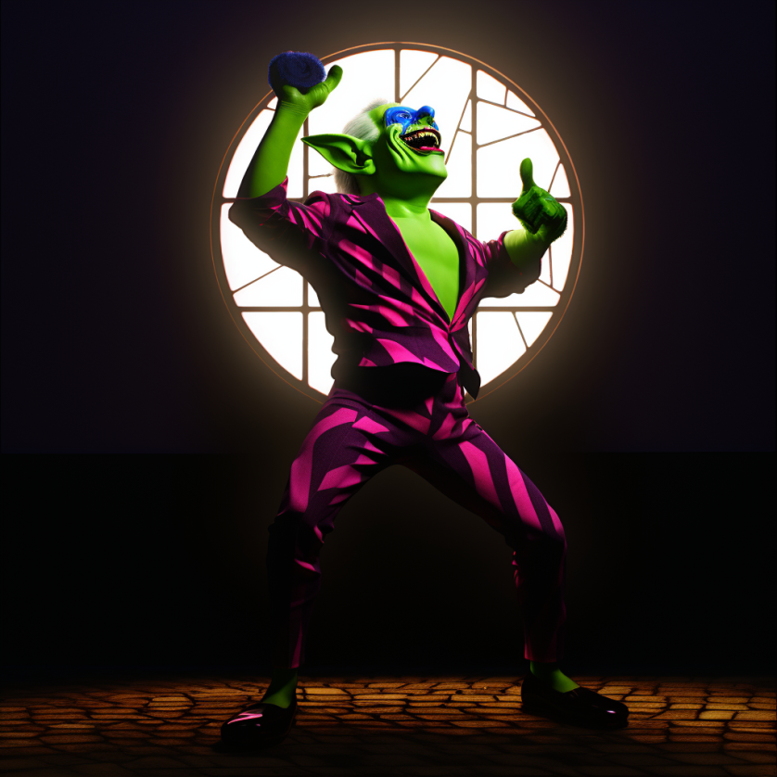

**1️⃣ a green character in a colorful suit and shirt in front of a large window, in the style of baroque dramatic lighting, dynamic pose, goblincore, colorful caricature, zbrush, brightly colored, bulbous**

**2️⃣ a green and purple character with glasses in front of a window, in the style of studio lighting, comical choreography, el greco, volumetric lighting, goblin academia, full body, greg hildebrandt**

**3️⃣ a video game character in a suit and glove, in the style of goblincore, realistic usage of light and color, comical choreography, don bluth, vivid colors, softbox lighting, kees van dongen**

**4️⃣ he has green eyes and a purple suit on his head, in the style of daz3d, comical choreography, goblincore, backlight, brightly colored, bulbous, full body**

[**https://s.mj.run/hCE-KxyddPE**](https://s.mj.run/hCE-KxyddPE) [**https://s.mj.run/djEO3tEIVL4**](https://s.mj.run/djEO3tEIVL4)

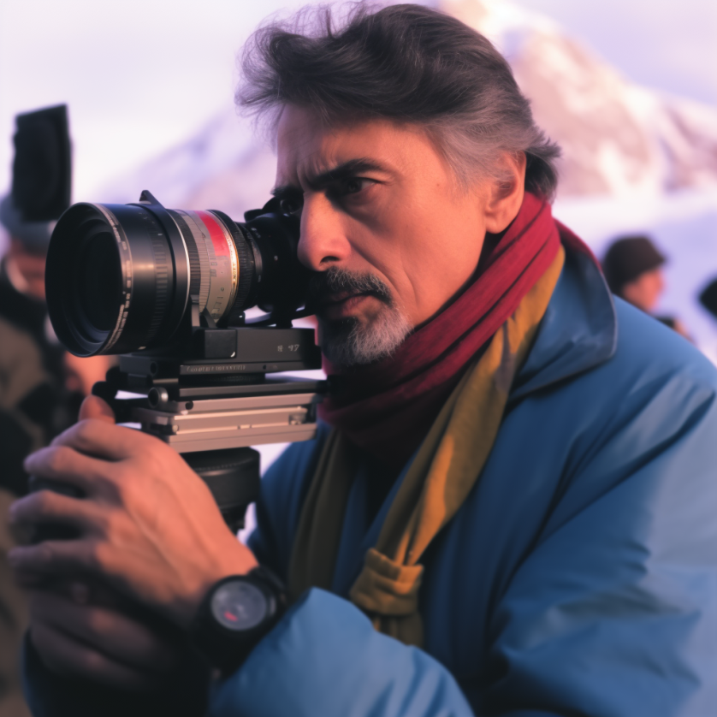

1️⃣ man in a blue scarf, camera lens and ski pants holding up a camera next to mountains, in the style of david , vincent desiderio, portraits with soft lighting, light gray and light crimson, bikash bhattacharjee, candid celebrity shots, precision of detail

2️⃣ a man holding a camera in the snow, in the style of dark pink and light indigo, movie still, soft-focused realism, mountainous vistas, celebrity photography, portraitist extraordinaire, italian landscapes

3️⃣ a man taking a picture with a camera, in the style of dark pink and gray, movie still, whistlerian, frozen movement, precise detailing, samikshavad, iconic

4️⃣ a man holding some kind of tool near the snowy landscape, in the style of celebrity photography, light maroon and gray, cooke speed panchro 50mm f/2, sandro botticelli, george lucas, dynamic and action-packed scenes, c-mount lens

[**https://s.mj.run/fmIUII2LOIU**](https://s.mj.run/fmIUII2LOIU) [**https://s.mj.run/MPPwMlGBdhs**](https://s.mj.run/MPPwMlGBdhs) [**https://s.mj.run/w9fFJxCNAj0**](https://s.mj.run/w9fFJxCNAj0)

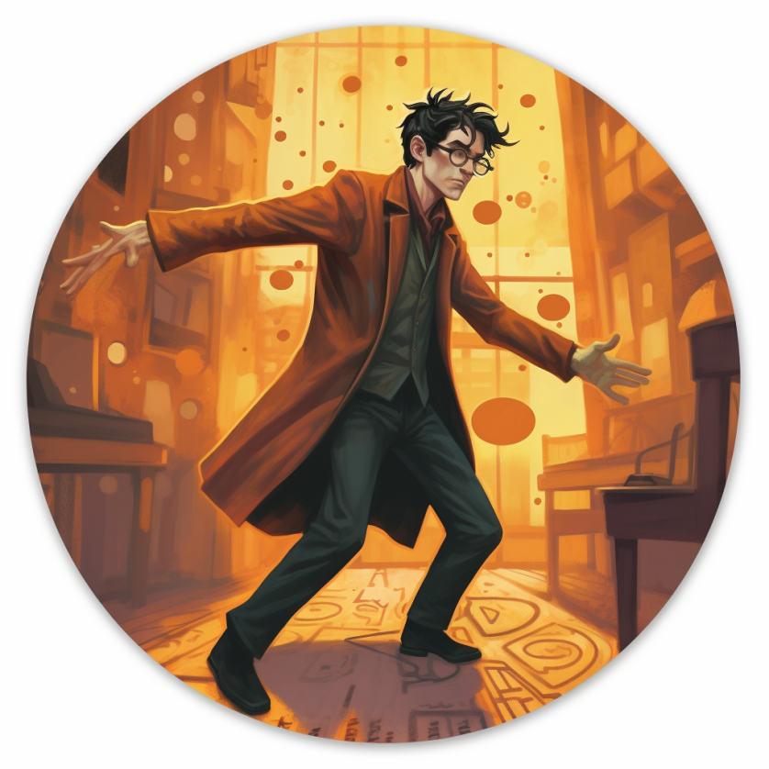

1️⃣ harry potter card 'loneliness', in the style of biomorphic, dark orange, tondo, official art, dynamic pose

2️⃣ henry potter t shirt by xie chiu, in the style of vibrant comics, rounded, digital painting, social commentary plaques, dynamic pose, crimson and amber, necronomicon illustrations

3️⃣ a illustration of a man in red pants wearing glasses and a hat, in the style of anna dittmann, lively action poses, greg rucka, social commentary plaques, harry shoulberg, dark yellow and orange, bunnycore

4️⃣ harry potter badge, harry potter bumblethor, in the style of cyril rolando, egon schiele, dynamic pose, greg rucka, orange, 1st version, internet academia

[**https://s.mj.run/ysBNgnIzKyE**](https://s.mj.run/ysBNgnIzKyE) [**https://s.mj.run/9kz9tI57hdA**](https://s.mj.run/9kz9tI57hdA)

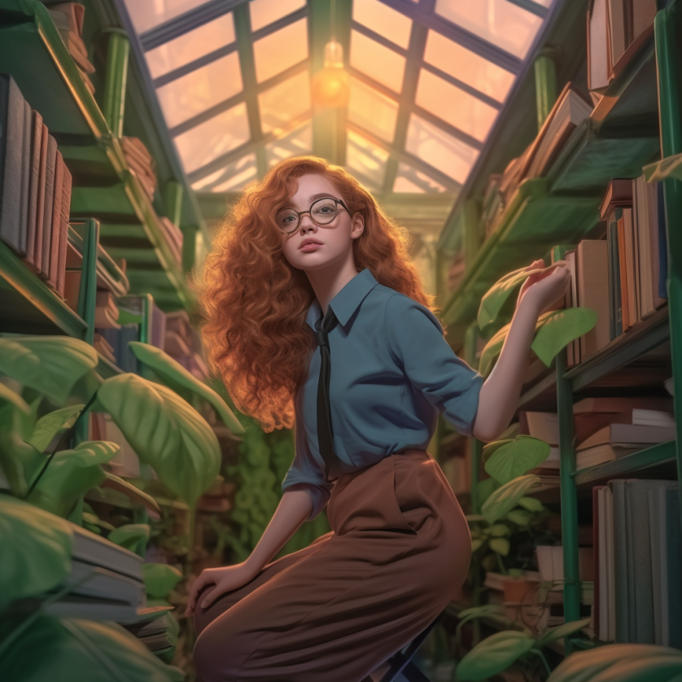

1️⃣ a blue woman with long red hair wearing glasses sitting in books shelves, in the style of highly detailed foliage, social media portraiture, fernando amorsolo, alex alemany, golden light, youthful protagonists, alex andreev

2️⃣ girl in glasses sitting in the library, in the style of tran nguyen, volumetric lighting, lively nature scenes, oleksandr bogomazov, artgerm, cluj school, mysterious jungle

3️⃣ a young woman in glasses sitting in the library, in the style of fantasy-inspired art, botanical abundance, hyper-realistic, sunrays shine upon it, youthful protagonists, caricature-like illustrations, metropolis meets nature

4️⃣ a girl in glasses wearing glasses is sitting on the floor of a library, in the style of realistic fantasy artwork, botanical abundance, volumetric lighting, lively nature scenes, american barbizon school, cryptid academia, cluj school

[**https://s.mj.run/YpETquhXzDY**](https://s.mj.run/YpETquhXzDY) [**https://s.mj.run/M99L4mImgmY**](https://s.mj.run/M99L4mImgmY)

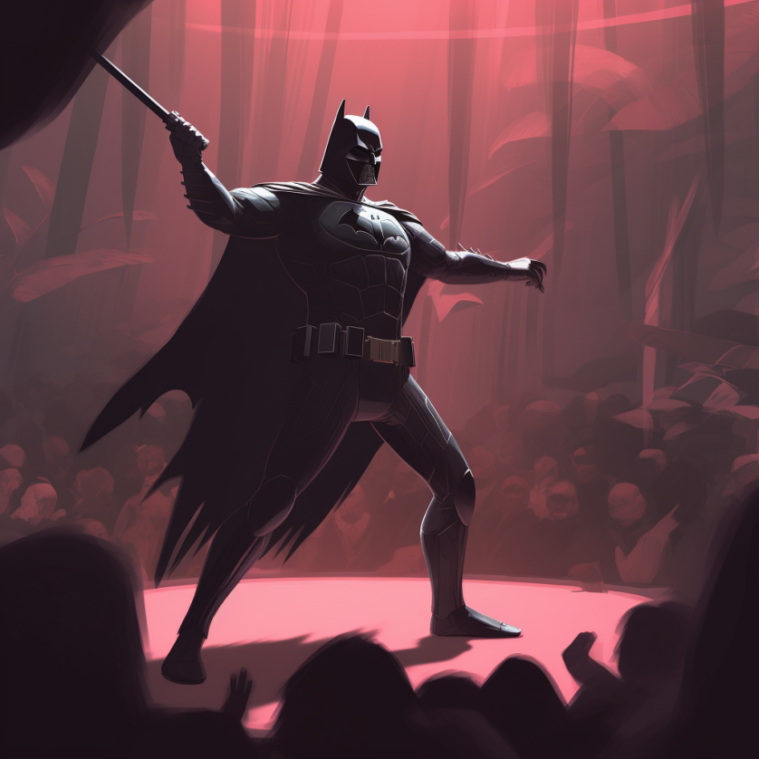

1️⃣ batman in the dark night by matthew samson, in the style of depictions of theater, aggressive digital illustration, lively movement, light crimson, whimsical genre scenes, monochromatic harmony, american barbizon school

2️⃣ batman standing in a dark room with a bat on his arm, in the style of aaron jasinski, detailed crowd scenes, expressive character design, george bellows, simplistic cartoon, rafał olbiński, light crimson

3️⃣ batman in a dungeon with his mask on in action, in the style of brushwork exploration, detailed crowd scenes, dark red and dark pink, depictions of theater, strong lines, heavy use of palette knives, simple, colorful illustrations

4️⃣ batman vs batman anime HD wallpapers, in the style of nicholas hely hutchinson, depictions of theater, george bellows, dark pink and dark gray, fantasy illustration, sketchy, light-filled scenes

[**https://s.mj.run/hnUKSEbAl90**](https://s.mj.run/hnUKSEbAl90) [**https://s.mj.run/oDmH9psAsJ0**](https://s.mj.run/oDmH9psAsJ0)

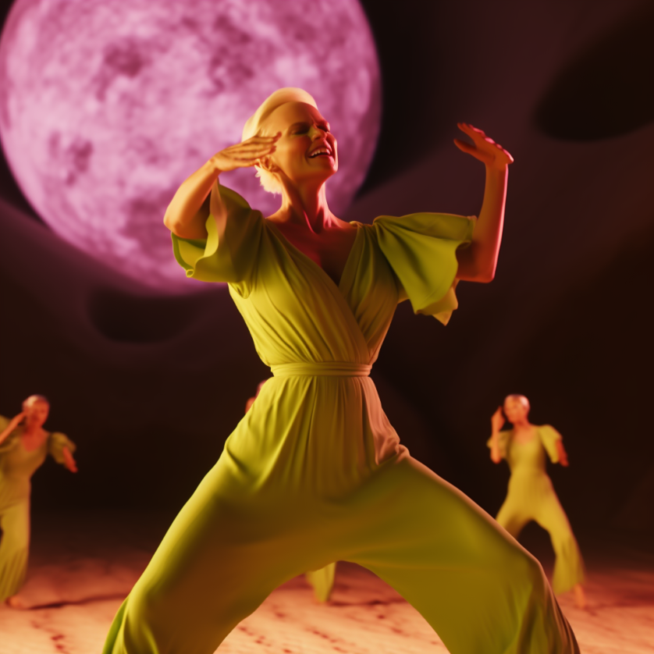

1️⃣ animated rendered woman dance in a green ensemble against a full moon, in the style of daz3d, sandy skoglund, purple and amber, joseph ducreux, steve , comical choreography, light yellow and light crimson

2️⃣ an animated drawing of a woman in green dance dress with a purple moon behind her, in the style of daz3d, national geographic photo, comical choreography, light orange

3️⃣ 3dfigure in yellow jumpsuit holding a stylized dance mat in front of a large white moon, in the style of inna mosina, ethereal figures, light red and green, cinestill 50d, veronika pinke, rendered in cinema4d, emil alzamora

4️⃣ the dancer performs in white and green outfits with moon in the background, in the style of rendered in cinema4d, dark yellow and light crimson, post-'70s ego generation, daz3d, national geographic photo, blink-and-you-miss-it detail, light orange and purple

[**https://s.mj.run/w0GkUt1BeuI**](https://s.mj.run/w0GkUt1BeuI) [**https://s.mj.run/H8lmyU17vPw**](https://s.mj.run/H8lmyU17vPw) [**https://s.mj.run/9jBYhU8W1LA**](https://s.mj.run/9jBYhU8W1LA)

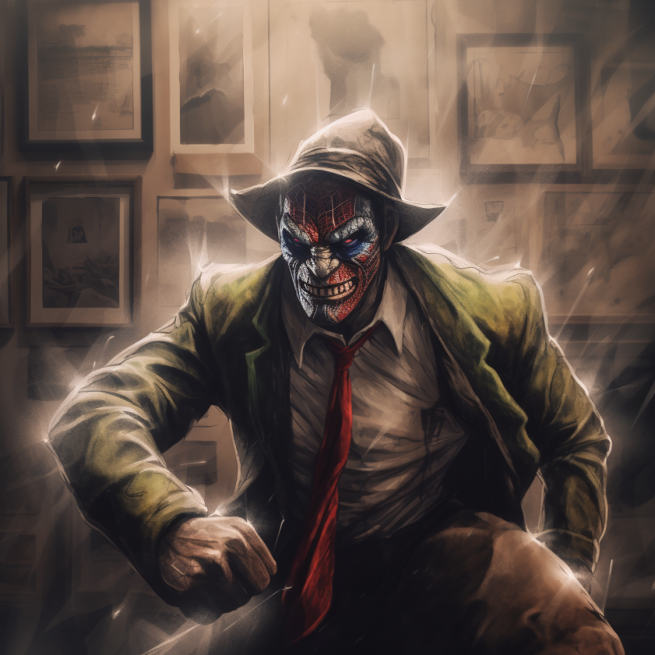

1️⃣ a man in a suit with a mask and tie, in the style of speedpainting, clowncore, paul hedley, cartoon violence, robert bateman, dc comics, joseph beuys

2️⃣ a cartoon of a clown dressed in a suit, in the style of speedpainting, goblin academia, gritty urban scenes, western-style portraits, dc comics, 8k, ritualistic masks

3️⃣ ko the villain , in the style of painterly scenes, clowncore, comic book noir, 8k, cryptid academia, western-style portraits, duckcore

4️⃣ dj dl clown by igor zhodin, in the style of comic book noir, 8k resolution, robert bateman, geoff johns, genre scenes, rough, takayuki takeya

[**https://s.mj.run/072HGXV_GyI**](https://s.mj.run/072HGXV_GyI) [**https://s.mj.run/fhjuuT4lH9M**](https://s.mj.run/fhjuuT4lH9M) [**https://s.mj.run/Vfrgf0fDtm0**](https://s.mj.run/Vfrgf0fDtm0)

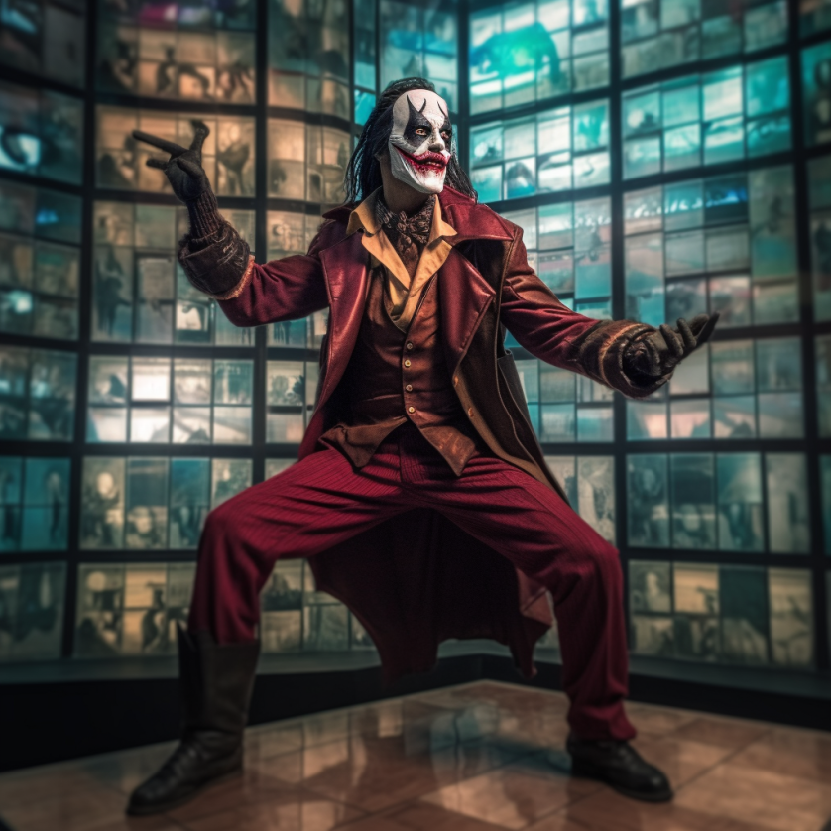

1️⃣ a joker with a mask standing on a wall, in the style of post processing, maroon, candid shots of famous figures, cyclorama, dc comics, nikon d850, theatrical installations

2️⃣ joker cosplay from the movie batman vs shark, in the style of social media portraiture, dark red, spectacular backdrops, cyberpunk, theatrical installations, national geographic photo, spontaneous gestures

3️⃣ a joker character in front of several screens, in the style of nikon d850, maroon, jan matejko, shot on 70mm, saturated, polixeni papapetrou, comic art

4️⃣ a clown in a mask stands in front of a dark room, in the style of maroon and gray, cybermysticpunk, snapshots of iconic hollywood stars, dc comics, nikon d850, polixeni papapetrou, rtx on